

**Year 12**

**General Biology**

**Task 7: Inheritance & Change Test**

**Multiple Choice Questions Booklet**

Multiple Choice Questions: **Use Answer Booklet**

1. If a mutation occurs in an individual, it can be passed onto the next generation if it…
2. Is a mutation of the somatic cells.
3. Occurs in the gametes producing offspring.
4. Is a change in the X and Y chromosomes.
5. Is caused by environmental factors.
6. Below is a graph of the incubation temperature effect on hatchling sex ratio in sea turtles. Refer to this graph in the following multiple-choice question.

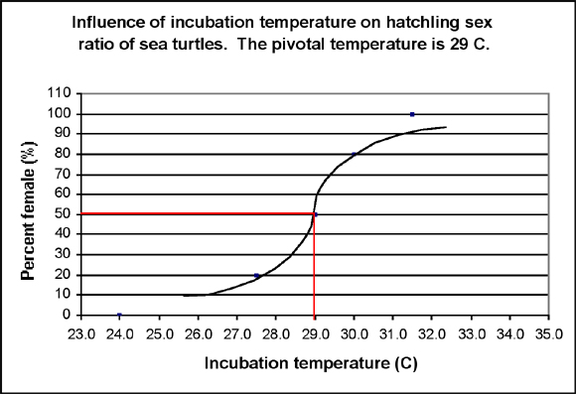

If the incubation temperature according to the graph is 30.0 degrees (C) the percentage of female hatchlings will be:

1. 10%
2. 50%
3. 80%
4. 100%
5. An important benefit of sexual reproduction in natural selection is that…
6. It provides for a mechanism of recombination, providing variations for offspring.
7. It requires less energy than asexual reproduction so that the organisms survive and reproduce at a greater rate.
8. The offspring survival rate is greater than for asexual reproduction.
9. The offspring require the same conditions for survival as the parents.
10. Which of the following statements about mutations is FALSE?
11. Mutations can occur in any cell that contains DNA.
12. Mutations can be inherited.
13. Any change in a DNA sequence is called a mutation.
14. A mutation always has a damaging effect on cells.
15. Selection pressures act directly on:
16. Chromosome number
17. The entire genome
18. Species in gene pool with favourable traits
19. Phenotype of the individual
20. One of the biggest ways that a species evolves in a population is survival through:
21. Parallel evolution
22. Divergent evolution
23. Natural selection
24. Sexual selection.
25. Genes for traits that help an organism be more successful reproductively can be expected to…
26. Cause it to evolve into a new species.
27. Become more common in the future.
28. Cause the extinction of the species.
29. Eventually be eliminated by natural selection.
30. Natural selection ensures that individuals:
31. Adapt to their environment
32. Adapt to mutations
33. Adapt to other species in the population
34. Adapt to their own phenotype
35. The structure of DNA may be described as:
36. Double helix
37. Ladder model
38. Coiled chromosome
39. Protein bound
40. A scientists conducted an experiment to determine the effect of environment on the colour of fur of a Himalayan rabbit. The Himalayan rabbit typically has a white coat except for its colder nose, feet, tail and ears, which are black. The scientists shaved an area of hair on the back of each rabbit, then placed an ice pack over the shaved area on one rabbit (A)

Interpreting graphics in **figure 1-1,** what is the independent variable in this experiment?

1. The fur of the rabbits is the variable.
2. The colour of the rabbit is the variable.
3. The time of year is the variable.
4. The ice (temperature is the variable).



**Year 12 General Biology**

**Task 7: Inheritance & Change Test**

**Answer Booklet**

Time Allocated: 50 minutes

Weighting 8.75%

**Name: ___________________________________________**

|  |  |  |  |
| --- | --- | --- | --- |
| **Multiple Choice** | **Short Answer** | **Extended Answer** | **Total** |
| /10 | /22 | /8 | /40 |

**SECTION ONE:**

Multiple choice answers. Cross (X) through the correct answer.

|  |  |  |  |  |
| --- | --- | --- | --- | --- |
| **1** | a | b | c | d |
| **2** | a | b | c | d |
| **3** | a | b | c | d |
| **4** | a | b | c | d |
| **5** | a | b | c | d |
| **6** | a | b | c | d |
| **7** | a | b | c | d |
| **8** | a | b | c | d |
| **9** | a | b | c | d |
| **10** | a | b | c | d |

**Short Answer Section: (14 marks)**

1. The diagram below is of genetic information are where it can be found. (4 marks)
2. **Add** the following labels to the diagram indicating each:

Chromosome DNA Genes Nucleus

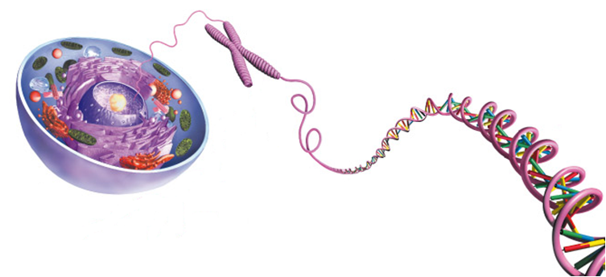

1. **Write** the complementary base pair to the following sequence: (1 mark)

**A G G T C C A T C G C A T A C G A C A C T A**

|  |
| --- |
|  |

1. **Discuss** how mutations bring new alleles into the gene pool and what affect this has on a population. (2 marks)

|  |
| --- |
|  |
|  |
|  |
|  |

1. **List** the two differences between somatic and germline mutation (2 marks)

|  |
| --- |
|  |
|  |
|  |

_________________________________________________________________________________

1. **Compare** and **contrast** artificial selection and natural selection in the venn below, **identifying** two similarities and two differences between the two selection processes.

(6 marks)

**Artificial Selection** **Natural Selection**

1. **Draw** and **label** a nucleotide in the box below. (3 marks)
2. **Discuss** how Natural Selection causes an impact on the survival and reproduction of peppered moths. (2 marks)

|  |
| --- |
|  |
|  |
|  |
|  |

1. **Explain** how the environment influences genetic expression in Hydrangeas. (2 marks)

|  |
| --- |
|  |
|  |
|  |
|  |

**Extended Response**

1. **Discuss** how genes and chromosomes determine the sex of an offspring, and **explain** the environmental influences on sex determination and their impact with the use of an example. (8 marks)

|  |
| --- |
|  |
|  |
|  |
|  |
|  |
|  |
|  |
|  |
|  |
|  |
|  |
|  |
|  |
|  |
|  |
|  |
|  |
|  |
|  |
|  |
|  |
|  |
|  |
|  |
|  |

**End of Assessment**